Broadcast
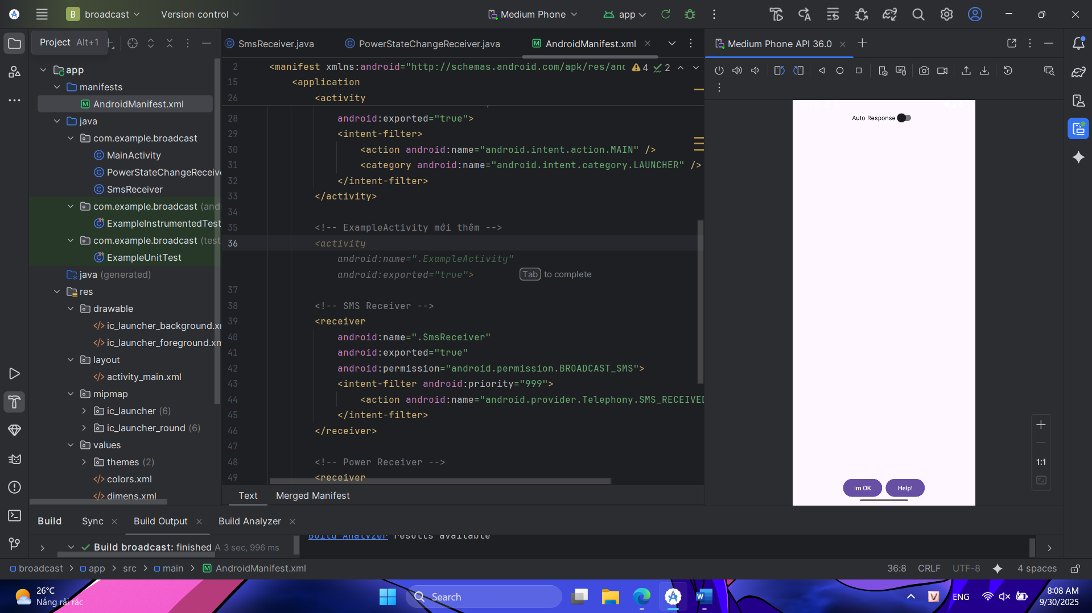
package com.example.broadcast;
import android.annotation.SuppressLint;
import android.content.BroadcastReceiver;
import android.content.Context;
import android.content.Intent;
import android.content.IntentFilter;
import android.content.SharedPreferences;
import android.os.Build;
import android.os.Bundle;
import android.telephony.SmsManager;
import android.view.View;
import android.widget.ArrayAdapter;
import android.widget.Button;
import android.widget.LinearLayout;
import android.widget.ListView;
import android.widget.Toast;
import androidx.appcompat.app.AppCompatActivity;
import androidx.appcompat.widget.SwitchCompat;
import java.util.ArrayList;
import java.util.concurrent.locks.ReentrantLock;
public class MainActivity extends AppCompatActivity {
public static final String SMS_MESSAGE_ADDRESS_KEY = "sms_address";
public static final String AUTO_RESPONSE = "auto_response_key";
public static boolean isRunning = false;
private ReentrantLock reentrantLock;
private ArrayList<String> requesters;
private ArrayAdapter<String> adapter;
private ListView lvMessages;
private SharedPreferences sharedPreferences;
private SharedPreferences.Editor editor;
private SwitchCompat swAutoResponse;
private LinearLayout llButtons;
private BroadcastReceiver broadcastReceiver;
@Override
protected void onCreate(Bundle savedInstanceState) {
super.onCreate(savedInstanceState);
setContentView(R.layout.activity_main);
lvMessages = findViewById(R.id.lvMessages);
swAutoResponse = findViewById(R.id.swAutoResponse);
llButtons = findViewById(R.id.llButtons);
initVariables();
initBroadcastReceiver();
swAutoResponse.setOnCheckedChangeListener((buttonView, isChecked) -> {
editor.putBoolean(AUTO_RESPONSE, isChecked);
editor.apply();
llButtons.setVisibility(isChecked ? View.GONE : View.VISIBLE);
if (isChecked && !requesters.isEmpty()) {
respond(true);
}
});
Button btnSafe = findViewById(R.id.btnSafe);
Button btnNotSafe = findViewById(R.id.btnNotSafe);
btnSafe.setOnClickListener(v -> respond(true));
btnNotSafe.setOnClickListener(v -> respond(false));
}
private void respond(String to, String message) {
reentrantLock.lock();
try {
if (requesters.contains(to)) {
SmsManager sms = SmsManager.getDefault();
sms.sendTextMessage(to, null, message, null, null);
Toast.makeText(this, "Replied to: " + to, Toast.LENGTH_SHORT).show();
requesters.remove(to);
adapter.notifyDataSetChanged();
}
} catch (Exception e) {
Toast.makeText(this, "Failed to send SMS to " + to, Toast.LENGTH_SHORT).show();
} finally {
reentrantLock.unlock();
}
}
private void respond(boolean isSafe) {
String message = isSafe
? getString(R.string.i_am_safe_and_well_worry_not)
: getString(R.string.tell_my_mother_i_love_her);
ArrayList<String> requestersCopy = new ArrayList<>(requesters);
for (String to : requestersCopy) {
respond(to, message);
}
}
private void processReceiveAddresses(ArrayList<String> addresses) {
if (addresses == null || addresses.isEmpty()) return;
boolean newAddressAdded = false;
for (String address : addresses) {
if (!requesters.contains(address)) {
requesters.add(address);
newAddressAdded = true;
}
}
if (newAddressAdded) {
adapter.notifyDataSetChanged();
}
if (swAutoResponse.isChecked()) {
respond(true);
}
}
private void initBroadcastReceiver() {
broadcastReceiver = new BroadcastReceiver() {
@Override
public void onReceive(Context context, Intent intent) {
if (SmsReceiver.SMS_FORWARD_BROADCAST_RECEIVER.equals(intent.getAction())) {
ArrayList<String> addresses = intent.getStringArrayListExtra(SMS_MESSAGE_ADDRESS_KEY);
processReceiveAddresses(addresses);
}
}
};
}
private void initVariables() {
reentrantLock = new ReentrantLock();
requesters = new ArrayList<>();
adapter = new ArrayAdapter<>(this, android.R.layout.simple_list_item_1, requesters);
lvMessages.setAdapter(adapter);
sharedPreferences = getPreferences(MODE_PRIVATE);
editor = sharedPreferences.edit();
boolean autoResponse = sharedPreferences.getBoolean(AUTO_RESPONSE, false);
swAutoResponse.setChecked(autoResponse);
llButtons.setVisibility(autoResponse ? View.GONE : View.VISIBLE);
Intent intent = getIntent();
if (intent != null && intent.hasExtra(SMS_MESSAGE_ADDRESS_KEY)) {
ArrayList<String> addresses = intent.getStringArrayListExtra(SMS_MESSAGE_ADDRESS_KEY);
processReceiveAddresses(addresses);
getIntent().removeExtra(SMS_MESSAGE_ADDRESS_KEY);
}
}
@SuppressLint("UnspecifiedRegisterReceiverFlag")
@Override
protected void onResume() {
super.onResume();
MainActivity.isRunning = true;
IntentFilter filter = new IntentFilter(SmsReceiver.SMS_FORWARD_BROADCAST_RECEIVER);
if (Build.VERSION.SDK_INT >= Build.VERSION_CODES.TIRAMISU) {
registerReceiver(broadcastReceiver, filter, Context.RECEIVER_NOT_EXPORTED);
} else {
registerReceiver(broadcastReceiver, filter);
}
}
@Override
protected void onPause() {
super.onPause();
MainActivity.isRunning = false;
unregisterReceiver(broadcastReceiver);
}
}
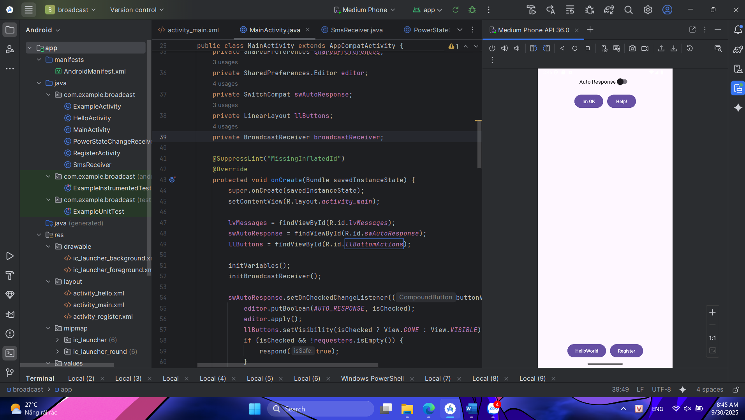
package com.example.broadcast;
import android.annotation.SuppressLint;
import android.content.BroadcastReceiver;
import android.content.Context;
import android.content.Intent;
import android.content.IntentFilter;
import android.content.SharedPreferences;
import android.os.Build;
import android.os.Bundle;
import android.telephony.SmsManager;
import android.view.View;
import android.widget.ArrayAdapter;
import android.widget.Button;
import android.widget.LinearLayout;
import android.widget.ListView;
import android.widget.Toast;
import androidx.appcompat.app.AppCompatActivity;
import androidx.appcompat.widget.SwitchCompat;
import java.util.ArrayList;
import java.util.concurrent.locks.ReentrantLock;
public class MainActivity extends AppCompatActivity {
public static final String SMS_MESSAGE_ADDRESS_KEY = "sms_address";
public static final String AUTO_RESPONSE = "auto_response_key";
public static boolean isRunning = false;
private ReentrantLock reentrantLock;
private ArrayList<String> requesters;
private ArrayAdapter<String> adapter;
private ListView lvMessages;
private SharedPreferences sharedPreferences;
private SharedPreferences.Editor editor;
private SwitchCompat swAutoResponse;
private LinearLayout llButtons;
private BroadcastReceiver broadcastReceiver;
@SuppressLint("MissingInflatedId")
@Override
protected void onCreate(Bundle savedInstanceState) {
super.onCreate(savedInstanceState);
setContentView(R.layout.activity_main);
lvMessages = findViewById(R.id.lvMessages);
swAutoResponse = findViewById(R.id.swAutoResponse);
llButtons = findViewById(R.id.llBottomActions);
initVariables();
initBroadcastReceiver();
swAutoResponse.setOnCheckedChangeListener((buttonView, isChecked) -> {
editor.putBoolean(AUTO_RESPONSE, isChecked);
editor.apply();
llButtons.setVisibility(isChecked ? View.GONE : View.VISIBLE);
if (isChecked && !requesters.isEmpty()) {
respond(true);
}
});
Button btnSafe = findViewById(R.id.btnSafe);
Button btnNotSafe = findViewById(R.id.btnNotSafe);
btnSafe.setOnClickListener(v -> respond(true));
btnNotSafe.setOnClickListener(v -> respond(false));
}
private void respond(String to, String message) {
reentrantLock.lock();
try {
if (requesters.contains(to)) {
SmsManager sms = SmsManager.getDefault();
sms.sendTextMessage(to, null, message, null, null);
Toast.makeText(this, "Replied to: " + to, Toast.LENGTH_SHORT).show();
requesters.remove(to);
adapter.notifyDataSetChanged();
}
} catch (Exception e) {
Toast.makeText(this, "Failed to send SMS to " + to, Toast.LENGTH_SHORT).show();
} finally {
reentrantLock.unlock();
}
}
private void respond(boolean isSafe) {
String message = isSafe
? getString(R.string.i_am_safe_and_well_worry_not)
: getString(R.string.tell_my_mother_i_love_her);
ArrayList<String> requestersCopy = new ArrayList<>(requesters);
for (String to : requestersCopy) {
respond(to, message);
}
}
private void processReceiveAddresses(ArrayList<String> addresses) {
if (addresses == null || addresses.isEmpty()) return;
boolean newAddressAdded = false;
for (String address : addresses) {
if (!requesters.contains(address)) {
requesters.add(address);
newAddressAdded = true;
}
}
if (newAddressAdded) {
adapter.notifyDataSetChanged();
}
if (swAutoResponse.isChecked()) {
respond(true);
}
}
private void initBroadcastReceiver() {
broadcastReceiver = new BroadcastReceiver() {
@Override
public void onReceive(Context context, Intent intent) {
if (SmsReceiver.SMS_FORWARD_BROADCAST_RECEIVER.equals(intent.getAction())) {
ArrayList<String> addresses = intent.getStringArrayListExtra(SMS_MESSAGE_ADDRESS_KEY);
processReceiveAddresses(addresses);
}
}
};
}
private void initVariables() {
reentrantLock = new ReentrantLock();
requesters = new ArrayList<>();
adapter = new ArrayAdapter<>(this, android.R.layout.simple_list_item_1, requesters);
lvMessages.setAdapter(adapter);
sharedPreferences = getPreferences(MODE_PRIVATE);
editor = sharedPreferences.edit();
boolean autoResponse = sharedPreferences.getBoolean(AUTO_RESPONSE, false);
swAutoResponse.setChecked(autoResponse);
llButtons.setVisibility(autoResponse ? View.GONE : View.VISIBLE);
Intent intent = getIntent();
if (intent != null && intent.hasExtra(SMS_MESSAGE_ADDRESS_KEY)) {
ArrayList<String> addresses = intent.getStringArrayListExtra(SMS_MESSAGE_ADDRESS_KEY);
processReceiveAddresses(addresses);
getIntent().removeExtra(SMS_MESSAGE_ADDRESS_KEY);
}
}
@SuppressLint("UnspecifiedRegisterReceiverFlag")
@Override
protected void onResume() {
super.onResume();
MainActivity.isRunning = true;
IntentFilter filter = new IntentFilter(SmsReceiver.SMS_FORWARD_BROADCAST_RECEIVER);
if (Build.VERSION.SDK_INT >= Build.VERSION_CODES.TIRAMISU) {
registerReceiver(broadcastReceiver, filter, Context.RECEIVER_NOT_EXPORTED);
} else {
registerReceiver(broadcastReceiver, filter);
}
}
@Override
protected void onPause() {
super.onPause();
MainActivity.isRunning = false;
unregisterReceiver(broadcastReceiver);
}
}

package com.example.broadcast;
import android.os.Bundle;
import android.widget.TextView;
import androidx.appcompat.app.AppCompatActivity;
public class ExampleActivity extends AppCompatActivity {
@Override
protected void onCreate(Bundle savedInstanceState) {
super.onCreate(savedInstanceState);
// Tạo TextView đơn giản không cần file XML
TextView tv = new TextView(this);
tv.setText("This is ExampleActivity");
tv.setTextSize(20f);
tv.setPadding(32, 32, 32, 32);
setContentView(tv);
}
}

package com.example.broadcast;
import android.os.Bundle;
import androidx.appcompat.app.AppCompatActivity;
public class HelloActivity extends AppCompatActivity {
@Override
protected void onCreate(Bundle savedInstanceState) {
super.onCreate(savedInstanceState);
setContentView(R.layout.activity_hello);
}
}
package com.example.broadcast;
import android.content.BroadcastReceiver;
import android.content.Context;
import android.content.Intent;
import android.widget.Toast;
public class PowerStateChangeReceiver extends BroadcastReceiver {
@Override
public void onReceive(Context context, Intent intent) {
String action = intent.getAction();
if (action == null) {
return;
}
if (action.equals(Intent.ACTION_POWER_CONNECTED)) {
Toast.makeText(context, R.string.power_connected, Toast.LENGTH_LONG).show();
} else if (action.equals(Intent.ACTION_POWER_DISCONNECTED)) {
Toast.makeText(context, R.string.power_disconnected, Toast.LENGTH_LONG).show();
}
}
}

package com.example.broadcast;
import android.os.Bundle;
import androidx.appcompat.app.AppCompatActivity;
public class RegisterActivity extends AppCompatActivity {
@Override
protected void onCreate(Bundle savedInstanceState) {
super.onCreate(savedInstanceState);
setContentView(R.layout.activity_register);
}
}

package com.example.broadcast;
import android.content.BroadcastReceiver;
import android.content.Context;
import android.content.Intent;
import android.os.Bundle;
import android.telephony.SmsMessage;
import java.util.ArrayList;
public class SmsReceiver extends BroadcastReceiver {
public static final String SMS_FORWARD_BROADCAST_RECEIVER = "sms_forward_broadcast_receiver";
public static final String SMS_MESSAGE_ADDRESS_KEY = "sms_address";
@Override
public void onReceive(Context context, Intent intent) {
String action = intent.getAction();
if (!"android.provider.Telephony.SMS_RECEIVED".equals(action)) {
return;
}
Bundle extras = intent.getExtras();
if (extras != null) {
Object[] smgs = (Object[]) extras.get("pdus");
ArrayList<String> addresses = new ArrayList<>();
if (smgs != null) {
for (Object pdu : smgs) {
SmsMessage smsMessage = SmsMessage.createFromPdu((byte[]) pdu);
String messageBody = smsMessage.getMessageBody();
if (messageBody != null && messageBody.toLowerCase().contains("are you ok?")) {
addresses.add(smsMessage.getOriginatingAddress());
}
}
}
if (!addresses.isEmpty()) {
if (MainActivity.isRunning) {
Intent iForward = new Intent(SMS_FORWARD_BROADCAST_RECEIVER);
iForward.putStringArrayListExtra(SMS_MESSAGE_ADDRESS_KEY, addresses);
context.sendBroadcast(iForward);
} else {
Intent iMain = new Intent(context, MainActivity.class);
iMain.addFlags(Intent.FLAG_ACTIVITY_NEW_TASK | Intent.FLAG_ACTIVITY_CLEAR_TOP);
iMain.putStringArrayListExtra(SMS_MESSAGE_ADDRESS_KEY, addresses);
context.startActivity(iMain);
}
}
}
}
}

<?xml version="1.0" encoding="utf-8"?>
<LinearLayout xmlns:android="http://schemas.android.com/apk/res/android"
android:layout_width="match_parent"
android:layout_height="match_parent"
android:orientation="vertical"
android:gravity="center"
android:padding="16dp">
<TextView
android:id="@+id/tvHello"
android:layout_width="wrap_content"
android:layout_height="wrap_content"
android:text="Hello from HelloActivity"
android:textSize="20sp"
android:textStyle="bold" />
</LinearLayout>

<?xml version="1.0" encoding="utf-8"?>
<LinearLayout xmlns:android="http://schemas.android.com/apk/res/android"
android:layout_width="match_parent"
android:layout_height="match_parent"
android:orientation="vertical"
android:gravity="center"
android:padding="16dp">
<TextView
android:id="@+id/tvRegister"
android:layout_width="wrap_content"
android:layout_height="wrap_content"
android:text="This is RegisterActivity"
android:textSize="20sp"
android:textStyle="bold" />
</LinearLayout>

<?xml version="1.0" encoding="utf-8"?>
<androidx.constraintlayout.widget.ConstraintLayout xmlns:android="http://schemas.android.com/apk/res/android"
xmlns:app="http://schemas.android.com/apk/res-auto"
xmlns:tools="http://schemas.android.com/tools"
android:id="@+id/main"
android:layout_width="match_parent"
android:layout_height="match_parent"
android:padding="16dp"
tools:context=".MainActivity">
<!-- Bật/tắt tự động phản hồi -->
<androidx.appcompat.widget.SwitchCompat
android:id="@+id/swAutoResponse"
android:layout_width="wrap_content"
android:layout_height="wrap_content"
android:text="@string/auto_response_label"
android:textSize="16sp"
app:layout_constraintTop_toTopOf="parent"
app:layout_constraintStart_toStartOf="parent"
app:layout_constraintEnd_toEndOf="parent" />
<!-- Safe / Not Safe -->
<LinearLayout
android:id="@+id/llSafeActions"
android:layout_width="wrap_content"
android:layout_height="wrap_content"
android:orientation="horizontal"
android:gravity="center"
android:layout_marginTop="12dp"
app:layout_constraintTop_toBottomOf="@id/swAutoResponse"
app:layout_constraintStart_toStartOf="parent"
app:layout_constraintEnd_toEndOf="parent">
<Button
android:id="@+id/btnSafe"
android:layout_width="wrap_content"
android:layout_height="wrap_content"
android:layout_marginEnd="12dp"
android:text="@string/respond_safe" />
<Button
android:id="@+id/btnNotSafe"
android:layout_width="wrap_content"
android:layout_height="wrap_content"
android:text="@string/respond_not_safe" />
</LinearLayout>
<!-- Danh sách tin nhắn -->
<ListView
android:id="@+id/lvMessages"
android:layout_width="0dp"
android:layout_height="0dp"
android:divider="@android:color/darker_gray"
android:dividerHeight="1dp"
android:layout_marginTop="12dp"
android:layout_marginBottom="12dp"
app:layout_constraintTop_toBottomOf="@id/llSafeActions"
app:layout_constraintBottom_toTopOf="@id/llBottomActions"
app:layout_constraintStart_toStartOf="parent"
app:layout_constraintEnd_toEndOf="parent" />
<!-- HelloWorld + Register -->
<LinearLayout
android:id="@+id/llBottomActions"
android:layout_width="wrap_content"
android:layout_height="wrap_content"
android:orientation="horizontal"
android:gravity="center"
android:layout_marginBottom="12dp"
app:layout_constraintBottom_toBottomOf="parent"
app:layout_constraintStart_toStartOf="parent"
app:layout_constraintEnd_toEndOf="parent">
<Button
android:id="@+id/btnHelloWorld"
android:layout_width="wrap_content"
android:layout_height="wrap_content"
android:layout_marginEnd="12dp"
android:onClick="onBtnHelloClick"
android:text="HelloWorld"
tools:ignore="OnClick" />
<Button
android:id="@+id/btnRegister"
android:layout_width="wrap_content"
android:layout_height="wrap_content"
android:onClick="onBtnRegisterClick"
android:text="Register"
tools:ignore="OnClick" />
</LinearLayout>
</androidx.constraintlayout.widget.ConstraintLayout>

<?xml version="1.0" encoding="utf-8"?>
<resources>
<string name="app_name">Broadcast Demo</string>
<!-- Thông báo trạng thái pin -->
<string name="power_connected">Power Connected</string>
<string name="power_disconnected">Power Disconnected</string>
<!-- Nội dung tin nhắn trả lời -->
<string name="i_am_safe_and_well_worry_not">I am safe and well, worry not!</string>
<string name="tell_my_mother_i_love_her">Tell my mother I love her!</string>
<!-- Nhãn giao diện -->
<string name="auto_response_label">Auto Response</string>
<string name="respond_safe">Im OK</string>
<string name="respond_not_safe">Help!</string>
</resources>

